FY 16-17 LUCENT Scholars

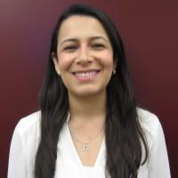
Nahiris Bahamon was born and raised in Colombia and came to the U.S as a refugee with her family at age 18. After graduating from UW-Madison with a
B.S in biology and anthropology as a Jack Kent Cooke Scholar, she worked as an Americorps health educator at Erie Family Health Center. Bahamon earned her MD degree from Boston University and is currently a PGY-2 in Comer Children's Hospital at the University of Chicago. Her
career interests include advocacy, universal access to health care, single payer, minority health, heath equity and disparities, the social determinants of health and the effects of climate change in health.

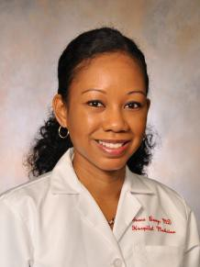
Grace Berry is an Internal Medicine physician who specializes in the care of medically complex patients in both the inpatient and outpatient settings at the University of Chicago. She attended Yale University where she received a Bachelor of Science in Biology. Following this, she received her medical degree from Columbia University College of Physicians and Surgeons and completed her Internal Medicine residency at New York-Presbyterian Hospital at Columbia University. After finishing residency, she joined the Comprehensive Care Program within the Section of Hospital Medicine. As a physician who was raised in the medically underserved area of central Brooklyn, her mission has always been to work in medical settings in areas of great medical need. Dr. Berry's interests include healthcare disparities, providing care for underserved populations, transitions of care, medical education and quality improvement. In particular, she is interested in innovative ways to improve quality of care and reduce healthcare costs for frequently hospitalized patients.

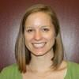
Katie Good received her undergraduate degrees in Biology and Religious Studies from the University of Virginia in 2010. She received her Medical Degree in 2014 from the Virginia Commonwealth University School of Medicine where she developed a passion for inner-city and underserved populations as part of the International-Inner City-Rural Preceptorship Honors program. She has extensive global health, volunteer, and teaching experience. She was thrilled to match at University of Chicago for a combined residency in Internal Medicine and Pediatrics. During her first two years of training, she has developed an interest in palliative care and its importance in the primary care setting. Katie is committed to working with underserved populations as a primary care physician and is excited to be a charter member of the LUCENT program.

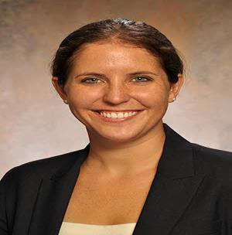
Rebecca Harris is currently a second year resident in the Internal Medicine program. She is originally from Oak Park, IL. She graduated from Washington University in St. Louis in 2006 with a major in anthropology and a minor in public health. She then took a year off to work for Heartland Alliance in Chicago, where she worked with refugee families and helped them learn English and navigate the healthcare system. She went on to get her medical degree at University of Chicago, and was excited to be able to stay for residency. She looks forward to pursuing a career in primary care!

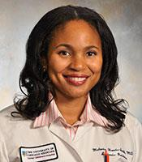
Dr. Melanie Harris-Smith is originally from Beachwood, Ohio and completed her Undergraduate education at Smith College in Northampton, MA. She then returned to her home state and completed her medical studies at University of Cincinnati College of Medicine in 2000. Her residency program at Christ Advocate Children's Hospital brought her to Chicago, where she has remained since 2000. She currently has 13 years of full time Pediatric practice as an Attending which has included Hospitalist inpatient duties as well as outpatient primary care, all of which has shaped her clinical experience and perspective in a positive way. She is currently a Clinical Associate with Comer Clinic, which is rewarding in the scope of patient acuity and demographic variance it provides. I also enjoy being a Teaching Attending, one afternoon a week , in the Pediatric Residency Continuity Clinic at Friend Family Health Center . My career interests are to grow in physician leadership and apply my current skills as an Attending clinician to triggering a positive impact on children's health outside the confines of office hours. I have strong networking skills that I wish to transform into leadership skills that will support my professional growth. Personally, I am a wife and mother of 3 amazing children: our son who is 10 and twin girls who are seven years old.

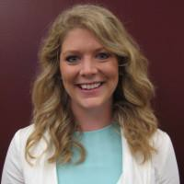
Kirsten Hollett has been working towards becoming a pediatrician for as long as she can remember. She completed a B.S. in Biochemistry and B.A. in Psychology from Wheaton College, where her academic aspirations were met with a call to serve people through providing medical care. She earned her
M.D. at Northwestern University, Feinberg School of Medicine, where her passion to commit to a career in pediatrics was confirmed. She is currently in her second year of pediatric residency at The University of Chicago, Comer Children's Hospital. She finds herself the happiest and most fulfilled after a busy day counseling families and watching children grow in her continuity clinic. She has a particular interest in child obesity and weight management. She aspires to become a leader in primary care in her community, an advocate for her patients, and a mentor in medical education.

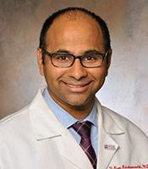
Ram Krishnamoorthi is an Assistant Professor of Medicine at the University of Chicago Medical Center and a former physician at the Hines Veterans Hospital. He provides primary care and hospital care for patients with complex medical and social problems in the Comprehensive Care Program, a project funded by a Center for Medicare Innovation grant to improve primary care and reduce hospitalization by improving continuity of care. In the Pritzker School of Medicine he co-directs the course on The American Healthcare System for the first year medical students. As Illinois state director for Doctors for America, a national grassroots organization of physicians who advocate improving access to quality health care for all Americans, he has organized medical students and physicians in letter-writing and public education campaigns, and has given a number of talks on the Affordable Care Act in the Chicago area. He graduated with his medical degree and Masters in public health from Northwestern Feinberg School of Medicine.

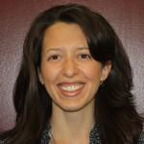
Meredithe McNamara is a recent graduate of the University of Chicago Pediatrics Residency Program. She attended medical school at Emory University in Atlanta, GA, where she also obtained a Master of Science in Clinical Research (MSCR). During residency, she pursued quality improvement work in trauma-informed care practices among physicians who care for pediatric patients affected by violence in Comer Children's and John
H. Stroger Hospitals. She will extend this work to primary care practices throughout Chicago's South Side as a Fellow with Project LUCENT and will devote half of her clinical time to the care of teenagers. Her focus is on Adolescent Medicine, particularly violence intervention and prevention, and female reproductive health.

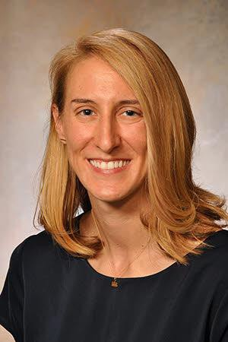
Hannah Wenger is a second-year resident in the internal medicine program at the University of Chicago. She is originally from central Pennsylvania. She attended college at Notre Dame and medical school at the University of
Chicago. She is planning to pursue a career in general medicine and primary care with a specific focus in LGBT medicine.

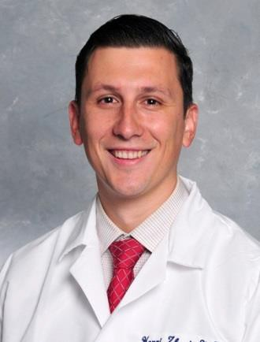

Henri Zhuri was born in Albania and immigrated to the United States in 1997. He completed an undergraduate degree in Biology at UMass, his medical school at Ross University, and is now in his second year of residency in the family medicine program at University of Chicago. His professional interests include preventative care in the underserved community, integrative health care, pain management, sports medicine, and women’s health. He is looking forward to being part of the LUCENT family in his role as a LUCENT scholar.

